Water Resources Integrated Modeling System Development Plan

**Draft Report**

**July 2010**

**Prepared under the supervision of**

Sanjaya Seneviratne

Senior Engineer

Modeling Support Branch, Bay-Delta Office

**Prepared by**

Kevin Kao

Engineer

Modeling Support Branch, Bay-Delta Office

# Proposed Improvements

## Simplify Debugging Process

To port XA LP solver, WRIMS either parses and compiles WRESL files into an executable that interact with the LP solver (in version 1.3), or calls XA Solver’s JAVA interface function directly (in version 2). From the WRESL files and input data, the linear programming variables, constraint matrices, and objective functions are processed and transmitted to the solver in the black box, without being displayed to the users. This opaque procedure slows down the debugging process considerably for both users and developers. Mostly the LP solver has to be invoked so that the output data and solver logs can be investigated to look for bugs. To simplify the debugging process, the input data transferred to the LP solver can be made transparent and easily accessible. For example, checkpoint files written in the de facto standard LP file format called “Mathematical Programming System (MPS)” can be generated between WRIMS and XA solver.

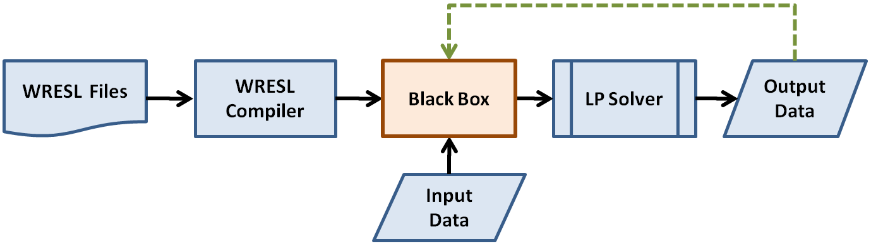

Figure . The linear programming information is processed and transmitted to the solver in the black box, without being displayed to the users.

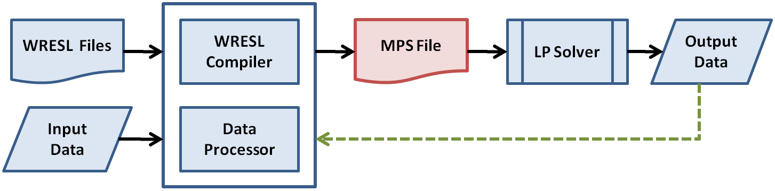

Figure . A standard Linear Programming file format called Mathematical Programming System (MPS) is generated to simplify the debugging process.

## Streamline Simultaneous Multi-Period Optimization

Multi-period optimization is useful for water allocation and management studies with some degree of foresight in hydrology. By assembling multi-period constraints and decision variables into “single set” of LP constraints and objective functions, multi-period optimization can be solved simultaneously instead of iteratively. For example, CalSim II Allocation Model (CAM) developed by Ryan Wilbur has demonstrated this capability. The WRESL compiler will be modified to simplify the coding procedure.

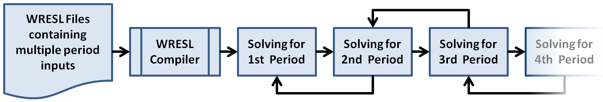

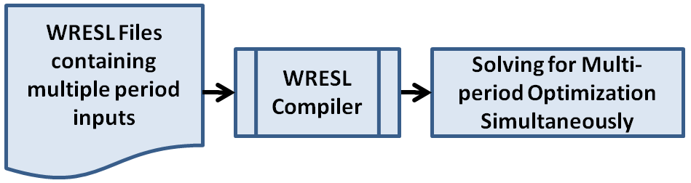

Figure . Iterative solution vs. simultaneous solution for multi-period optimization

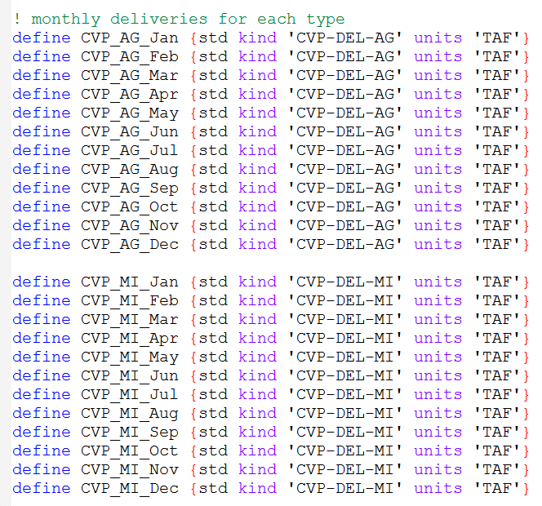

Figure . Coding style in CalSim Allocation Model (CAM)

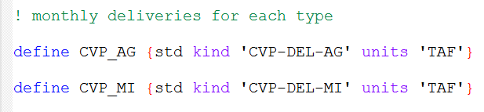

Figure . Coding style with new WRESL compiler

## Modular Design for Controller User Interface and WRIMS Engine

An input file containing study configurations and paths to additional input files can be generated from: (1) WRIMS desktop controller GUI, (2) WRIMS web user interface, or (3) user’s own scripts. This provides flexible scripting and batch processing without the need to invoke WRIMS desktop controller GUI.

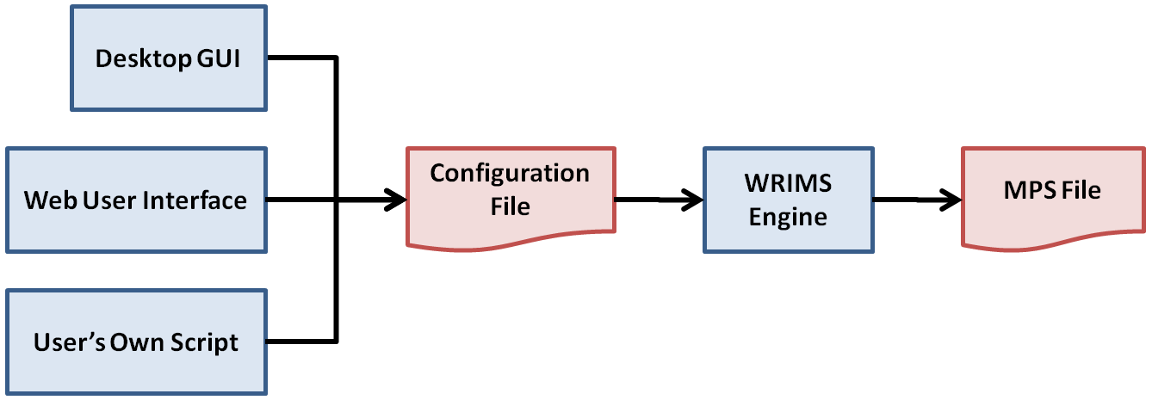

Figure . A study configuration file can be generated from the desktop controller GUI, web user interface, or user’s own script. This provides flexible scripting and batch processing without invoking the desktop controller GUI.

## Version Control with Database

One solution is using Subversion software to version control WRESL and study configuration files. Subversion is an open source tool that is reliable and readily available.

## Automate Self-Checking Tests

Debugging for WRIMS can be improved if the input data transferred to LP solvers is transparent and easily accessible to both modelers and developers. The input data includes LP variables, constraint matrices, and objective functions. and data is difficult and time-consuming because the data transfer from WRIMS to XA solver is not transparent. To port XA solver, WRIMS either writes FORTRAN codes (in version 1.3), or calls XA’s JAVA interface function directly (in version 2). The de facto standard file format for linear and integer programming called “Mathematical Programming System”, or MPS, is not generated as the check-point between WRIMS and XA solver.

## Incremental Parser for WRESL Language

All

### List Types Incremental Compilation

To list items within a sentence, give one, two, and three. To emphasize the number of items, give (1) one, (2) two, and (3) three.

## Modular Syntax for WRESL Language

All CTRE reports should have a technical report documentation page (first page of this template), with identifying information and an abstract. The technical report documentation page follows the front cover for the convenience of the sponsor and readers. The abstract will also be used to communicate the project results on the web.

# Development Schedule

## Phase 1 (08/2010 – 12/2010)